1.Elevate your user access to root;

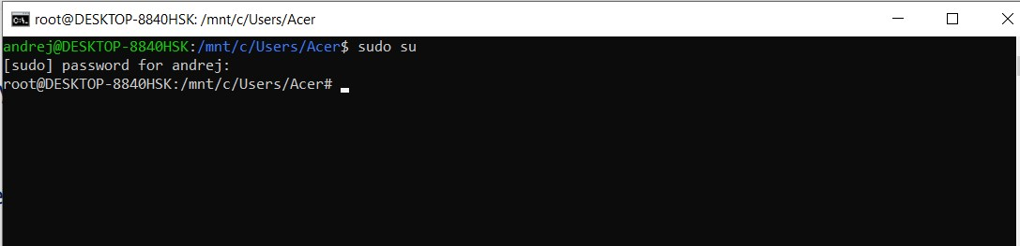

2.add a new user to your Linux OS and set a password for it;

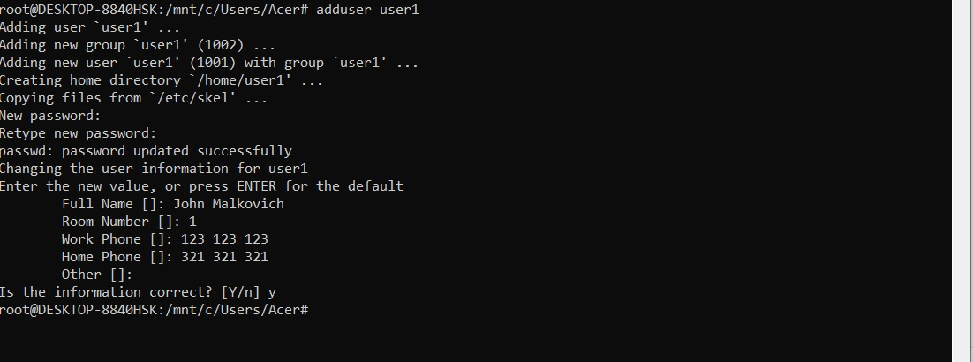

3.Test if you can log in using that user;

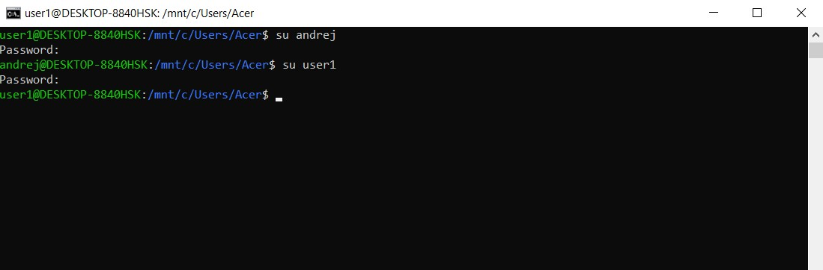

4.Using grep command check if the user is created;

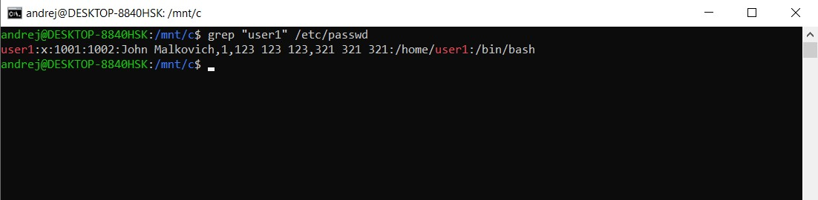

5.grep the UID of each user;

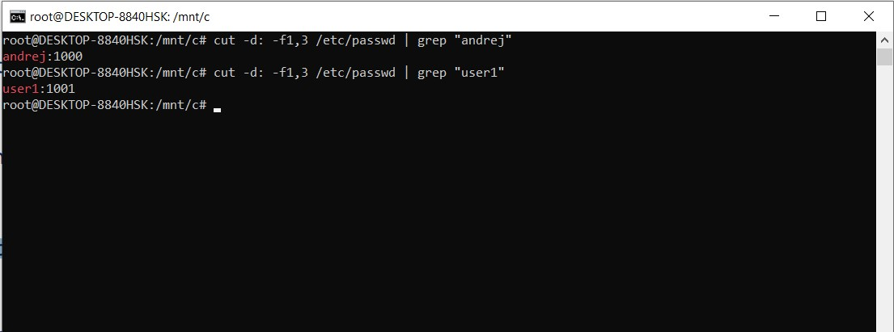

6.Find out the GID of the created user;

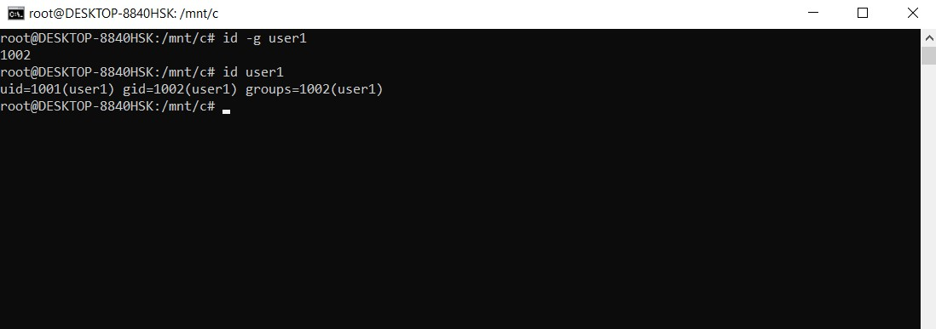

7.Change the password of the user and force it to change the pass on his next login;

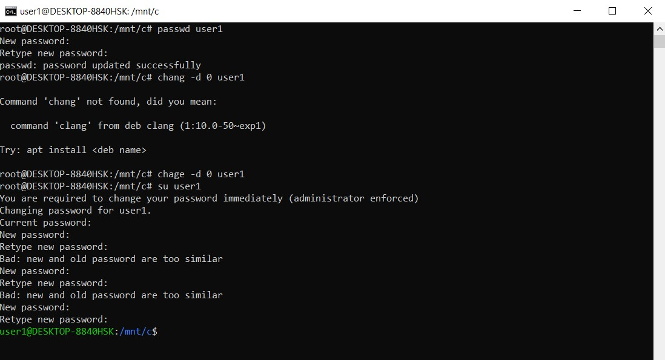

8.Add a new user and set an expiration date for it, with a five-day warning period;

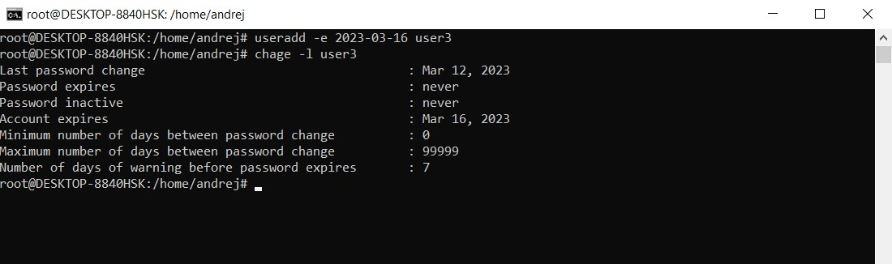

9.Create a new group; 10.Assign the two new users to that group;

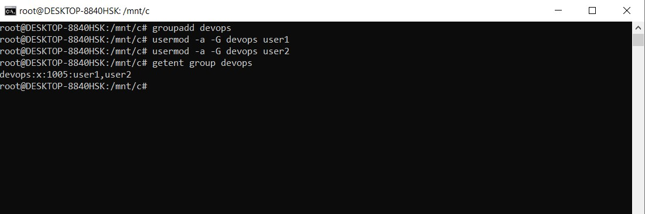

11.Lock one of the user accounts;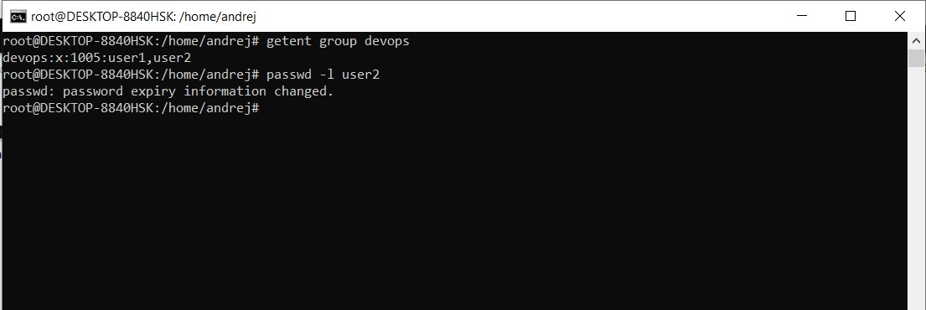

12.Change the shell of one user to rbash;

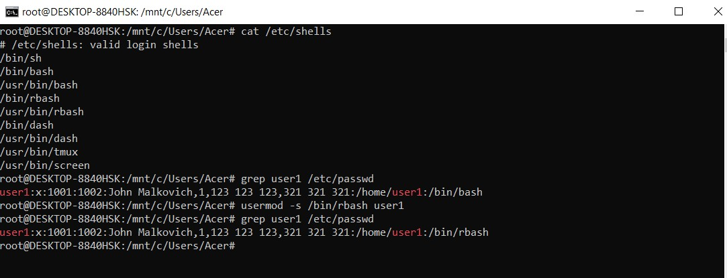

13.Make sure your home directory has “execute”access enabled for group and other.

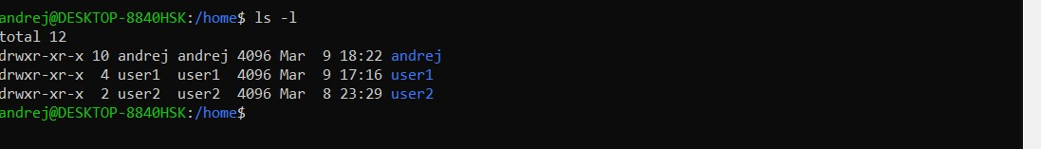

14.Change to your home directory, and create a directory called labs;

15.Create an empty file in labs directory

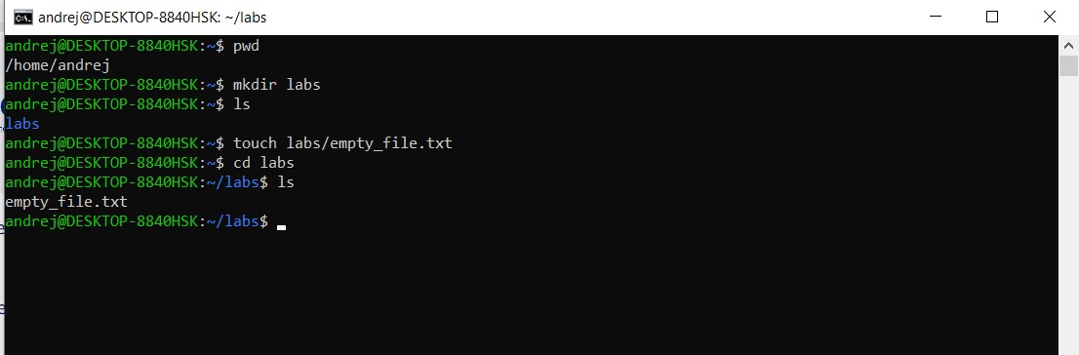

16.Change permissions of file to rwx-rwx-rwx

17.List the file. What color is the file?

18.Change the permissions back to rx-rw-rw

19.Check what owners does the file have.

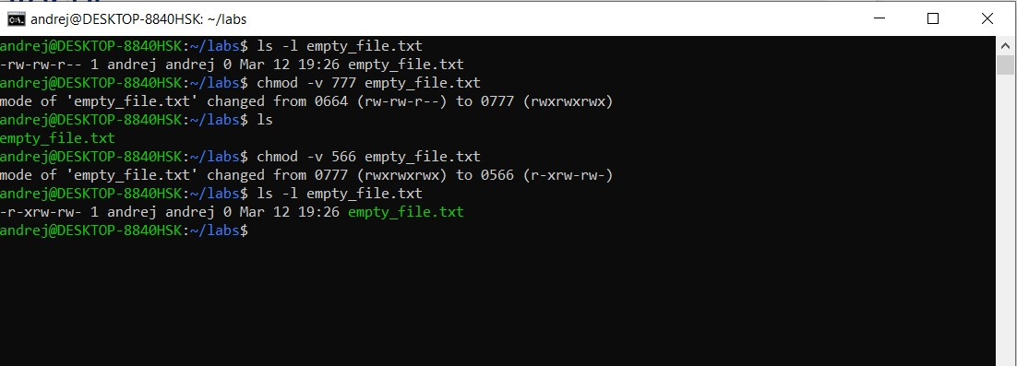

20.Change the user ownership of the file to another user;

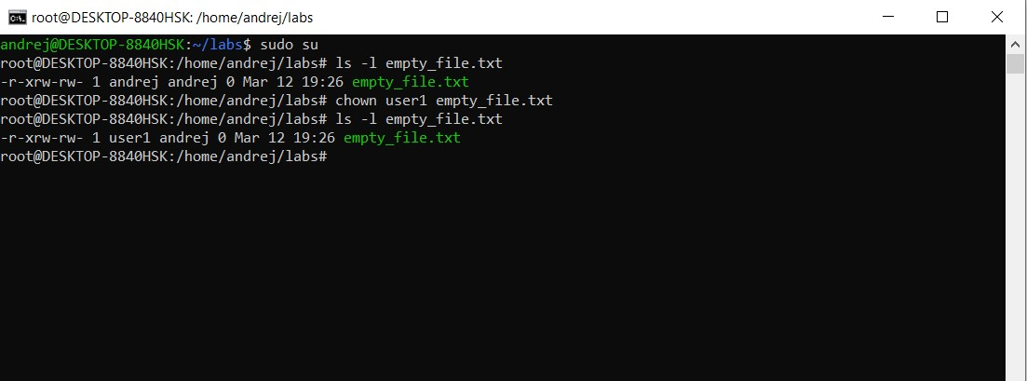

21.Create a group called group1 and assign two users to the group;

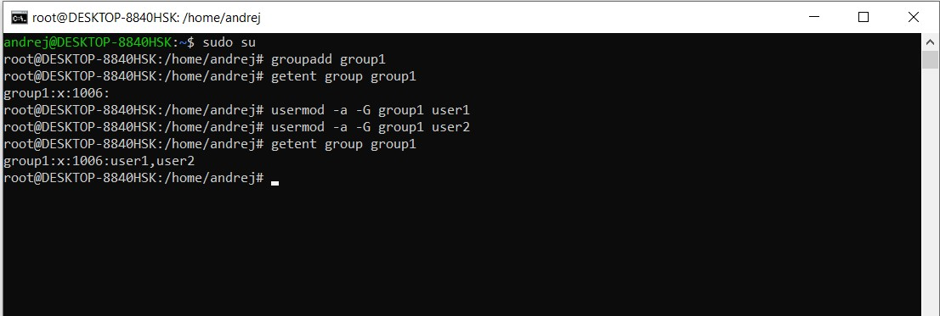

22.Create a file called group1.txt and redirect below input into the file: “This is our group test file”.

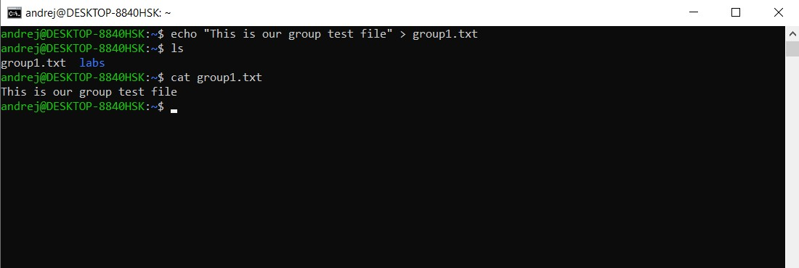

23.Change the group of the file to one of your users;

24.Give members of the group group1 read/write access to this file?

